Business Intelligence Lab
Unit 1 | Session 3
Experiment 3
Dimensional Modeling and Star Schema Design using Microsoft Power BI

Aim
To design and implement a dimensional model using Microsoft Power BI by converting transactional data into a structured Star Schema.

Tools / Software Required
1. Microsoft Power BI Desktop
2. Global Superstore Dataset.xlsx
3. Power Query Editor (Built into Power BI Desktop)
4. DAX (Data Analysis Expressions)
Dataset Source:
Global Superstore Dataset (Kaggle)
https://www.kaggle.com/datasets/apoorvaappz/global-super-store-dataset

Theory
Dimensional modeling is a data modeling technique used to organize data in a simple and efficient structure for reporting, analysis, and decision-making. It converts complex transactional data into a structured model that allows users to easily analyze business information.
In Microsoft Power BI, dimensional modeling is commonly implemented using a Star Schema. A Star Schema consists of a central Fact Table surrounded by several Dimension Tables.

1. Fact Table
A Fact Table contains measurable and quantitative business data. It represents business events or transactions.
For example, a sales fact table may contain:
- Sales ID
- Customer ID
- Product ID
- Date ID
- Quantity
- Sales Amount
- Discount
The fact table usually contains a large number of rows and uses foreign keys to connect with dimension tables.

2. Dimension Table
A Dimension Table contains descriptive information about the facts. Dimensions provide the context required to analyze the measures stored in the fact table.
Common dimension tables include:
- Customer Dimension – Customer ID, Name, City, Country
- Product Dimension – Product ID, Product Name, Category, Brand
- Date Dimension – Date, Day, Month, Quarter, Year
- Location Dimension – City, State, Region, Country
Dimension tables generally have a unique primary key that is referenced by the fact table.

3. Star Schema
A Star Schema is a dimensional model where a central fact table is directly connected to multiple dimension tables.

Conduct
Part A: Extract – Connect to Dataset
Step 1: Load Dataset.
Step 2: Open Power BI Desktop.
Home > Get Data > Excel Workbook
Select Global Superstore Dataset.xlsx
Click Transform Data.
Step 3: Import the following worksheets:
• Orders
• Returns
• People
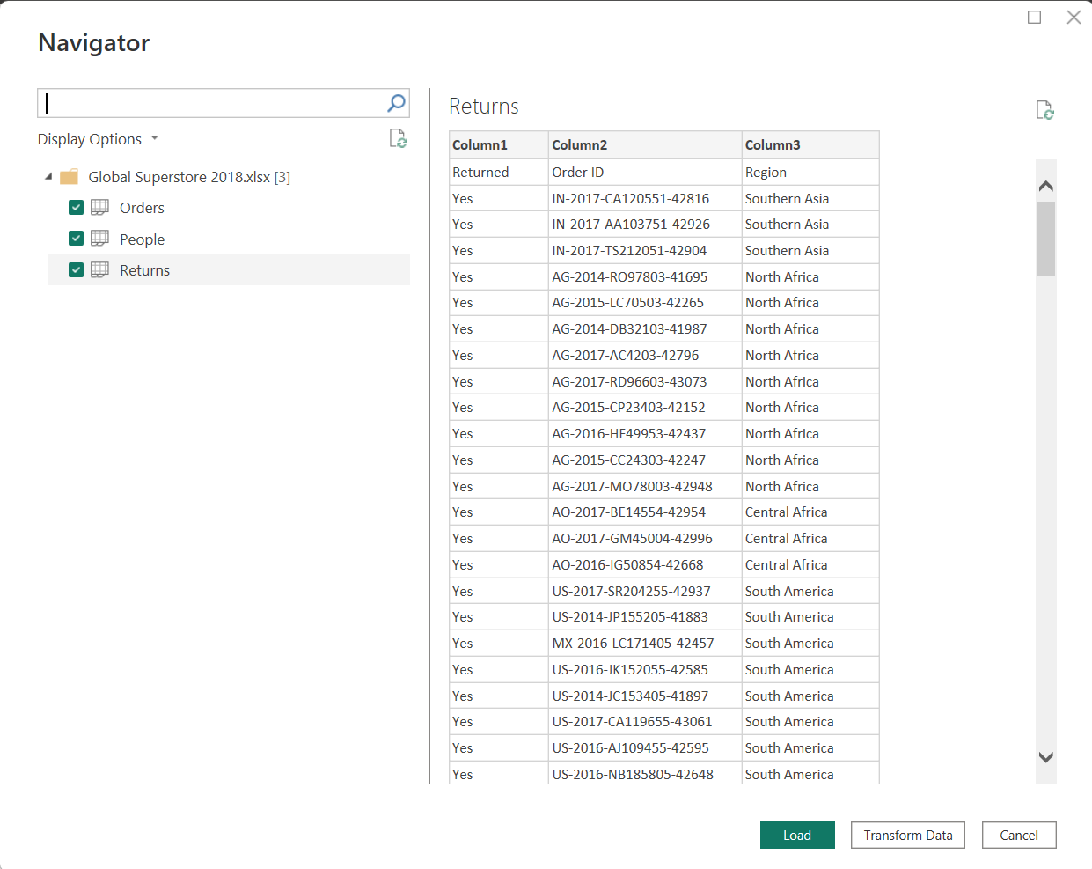

Part B: Explore Data
Step 4: Analyse the Orders Table to identify key business attributes.
Identify Fact Columns.
Identify Dimension columns.
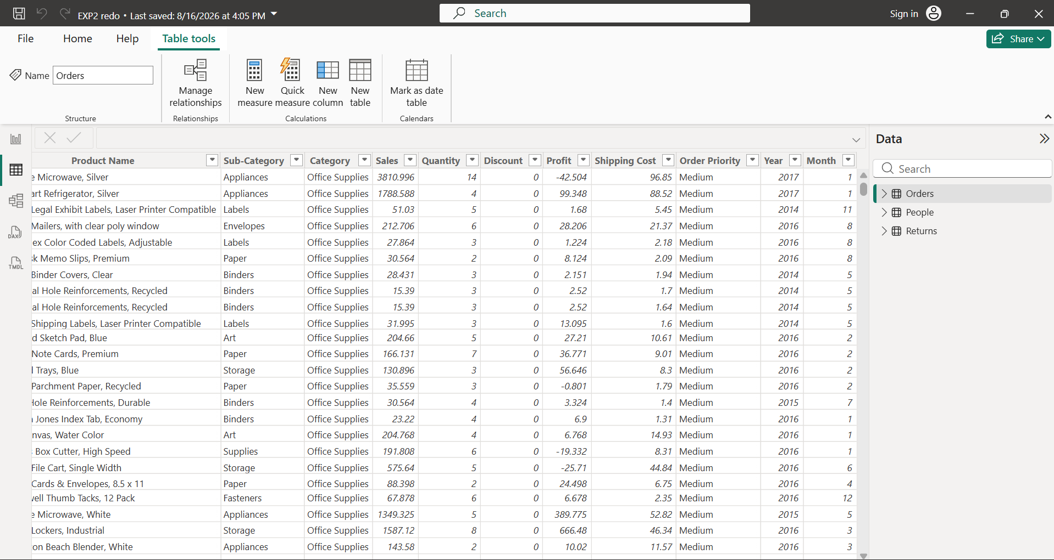
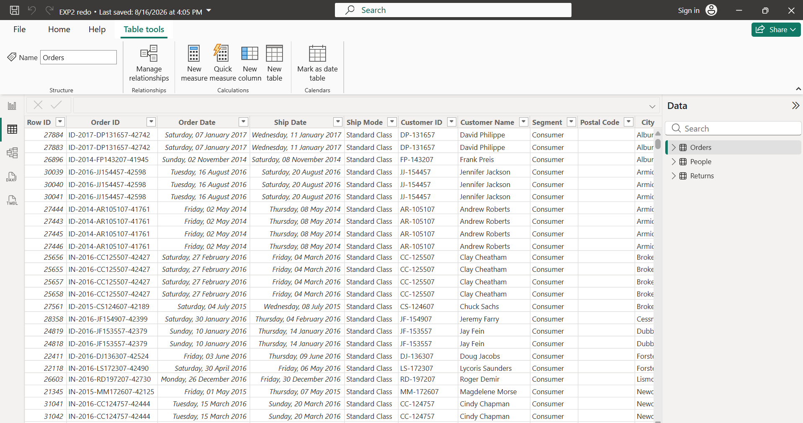Step 5: Apply the following transformations to the Orders table:
• Right-click Orders
- Choose Reference
- Rename it (Dim_Customer)
- Keep only:
- Customer ID
- Customer Name
- Segment
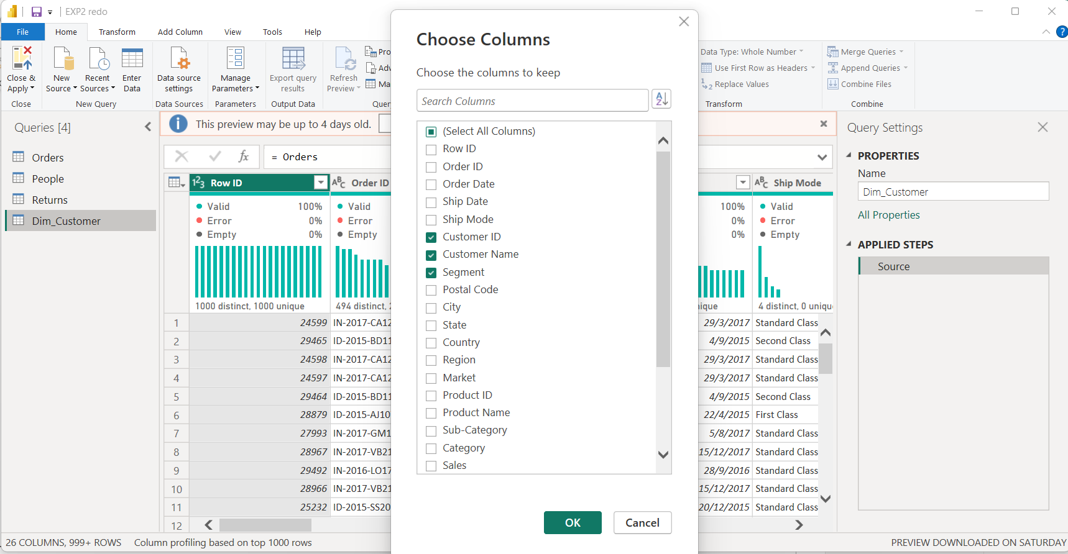
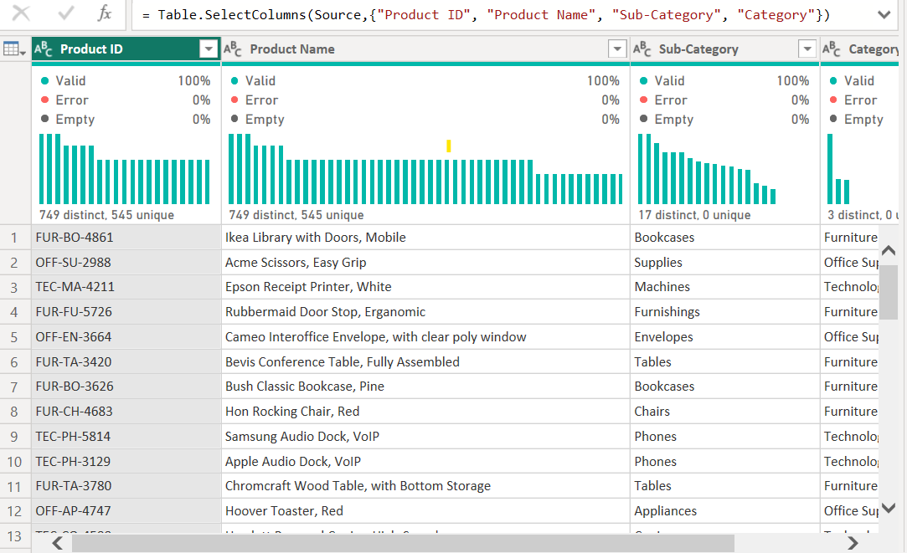
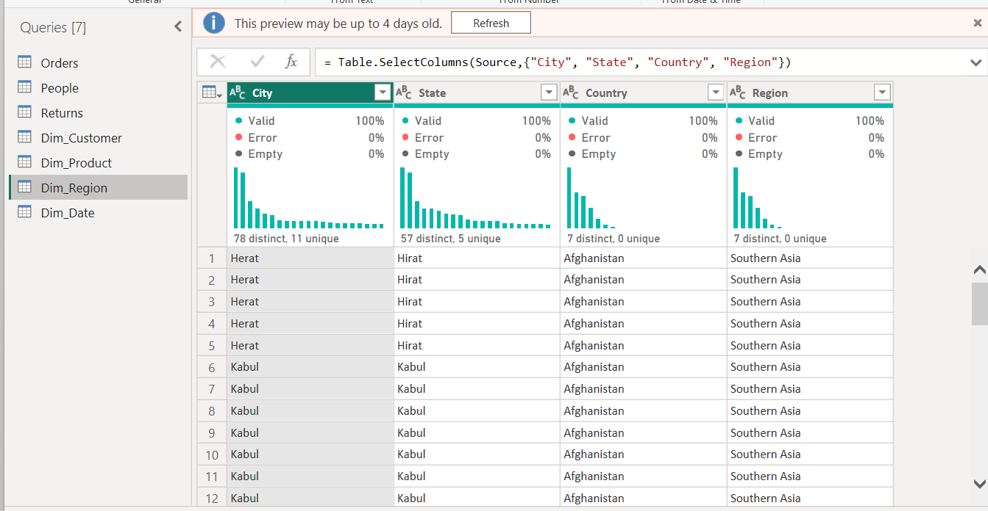
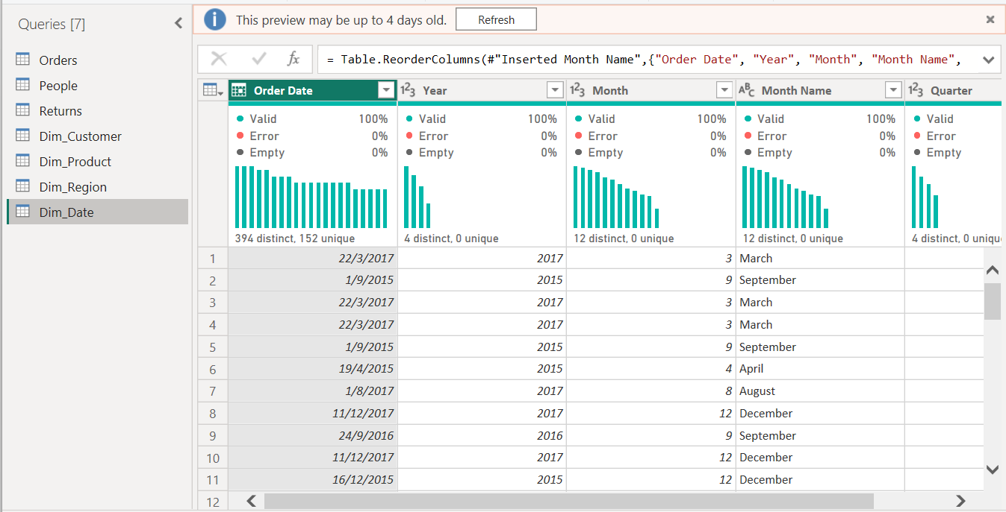
Step 6: Transform the Returns table:
• Remove duplicate Order IDs
• Check for missing values
• Standardize Returned field values
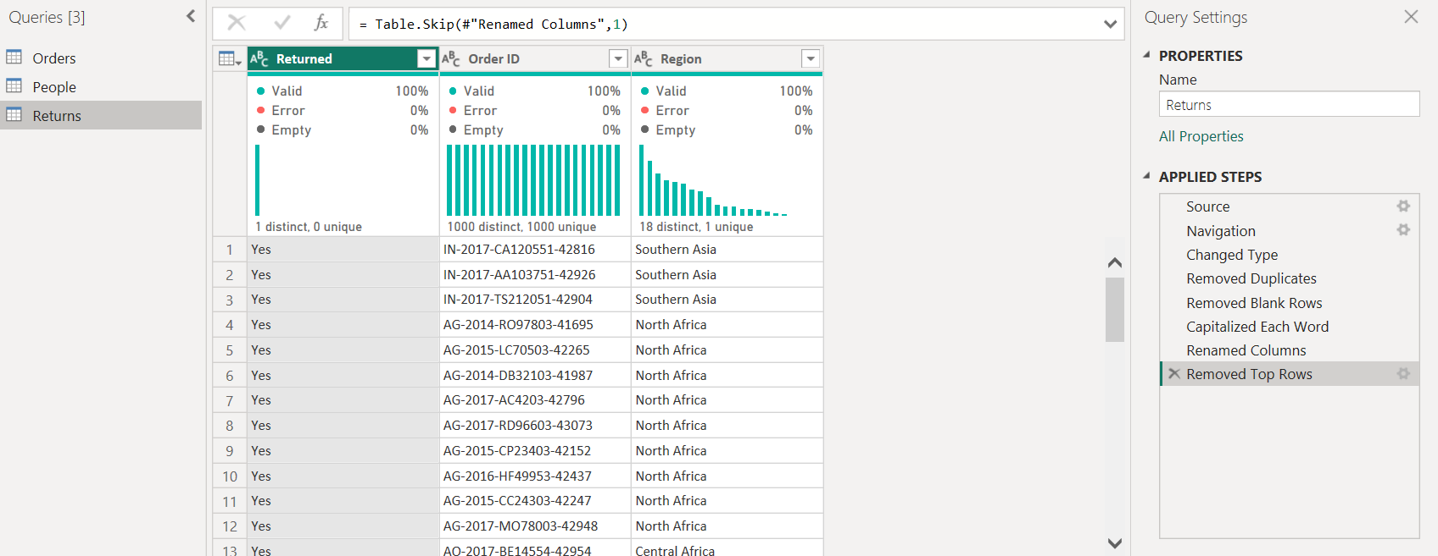
Step 7: Create relationships using:
- Customer ID
- Product ID
- Region
- Order Date
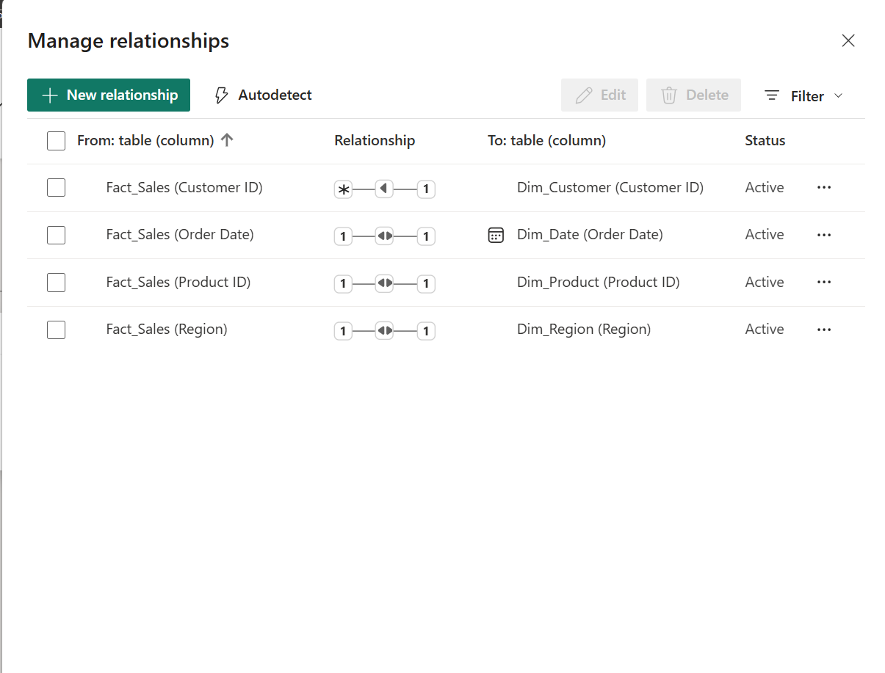
Step 8: Merge Orders and Returns tables using Order ID.
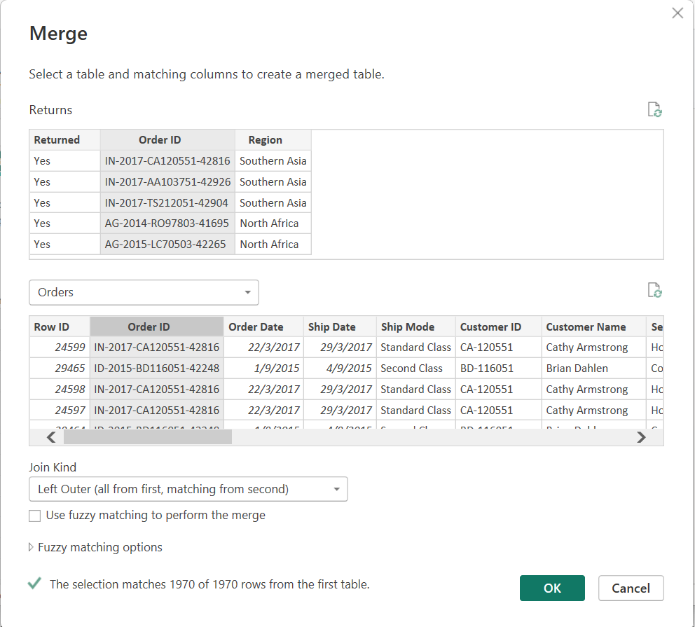
Step 9: Review the Star Schema
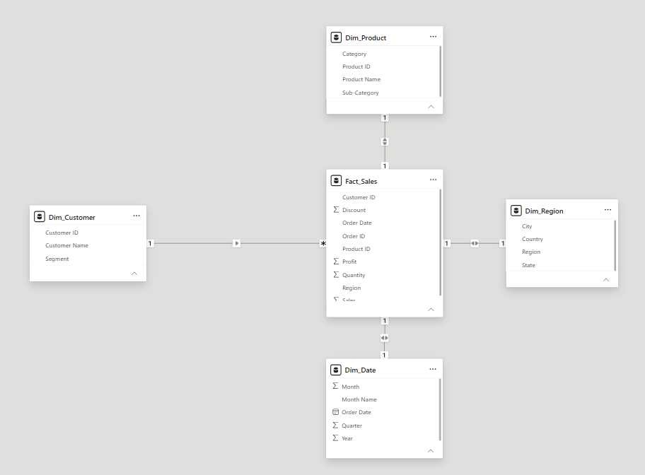

Part C: DAX Measures
Step 10: Navigate to Model View.
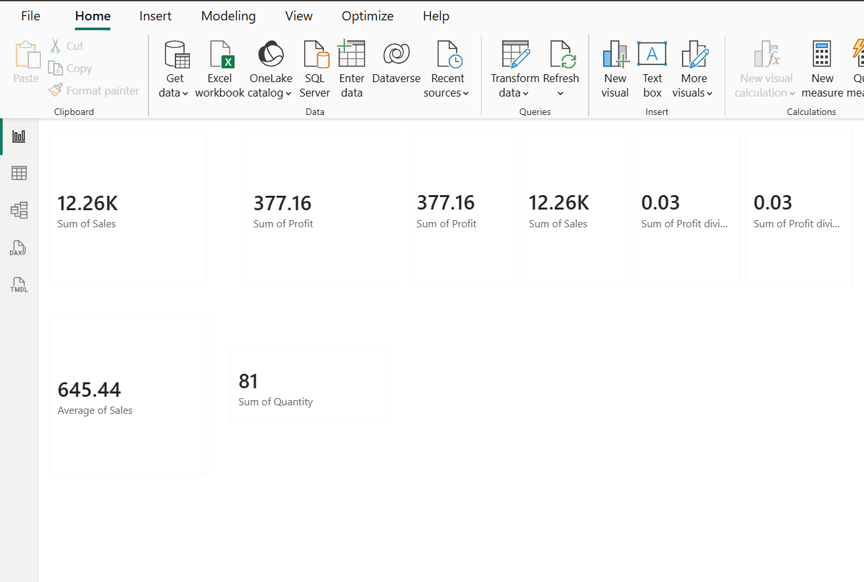
Step 11: Report Creation:
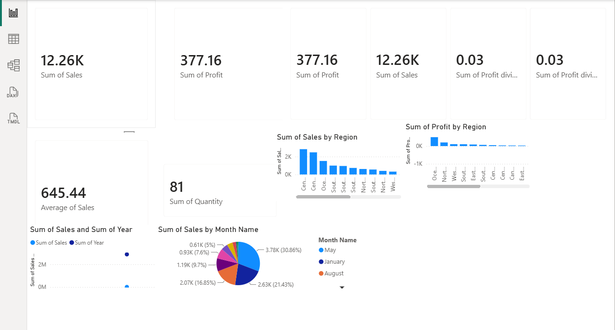

Result
A structured Star Schema is successfully implemented in Power BI, with a central Fact_Sales table connected to Dim_Customer, Dim_Product, and Dim_Date. The model can then be used to generate interactive analytical reports and dashboards.

Learning Outcomes
After completing this experiment, students will be able to:
- Understand dimensional modeling and Star Schema architecture.
- Differentiate between fact and dimension tables.
- Transform transactional data into an analytical data model.
- Create and manage relationships in Power BI.
- Write basic DAX measures.
- Build interactive dashboards using a dimensional model.

